

**Documentation of e-Project**

**GROUP MEMBERS**



| **Saniya Khan** | **Student1424835** |
| --- | --- |
|  |  |
| **Submitted To :** eprojects@aptechfze.ae    **Project Instructor : Mrs. Kaneez Fatima** |  |
| **Curriculum Code : OV-ACCP-PRIME (7062)** |

**MAIN CODING (PHP):**

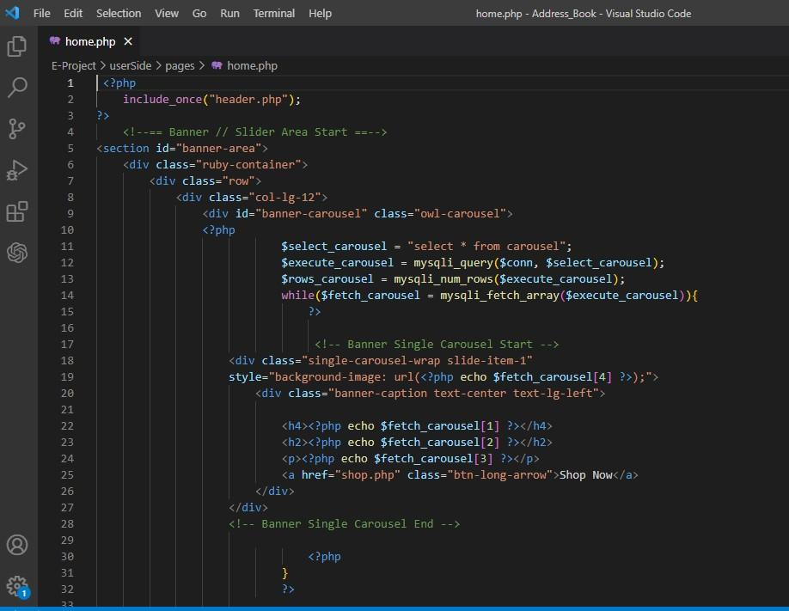

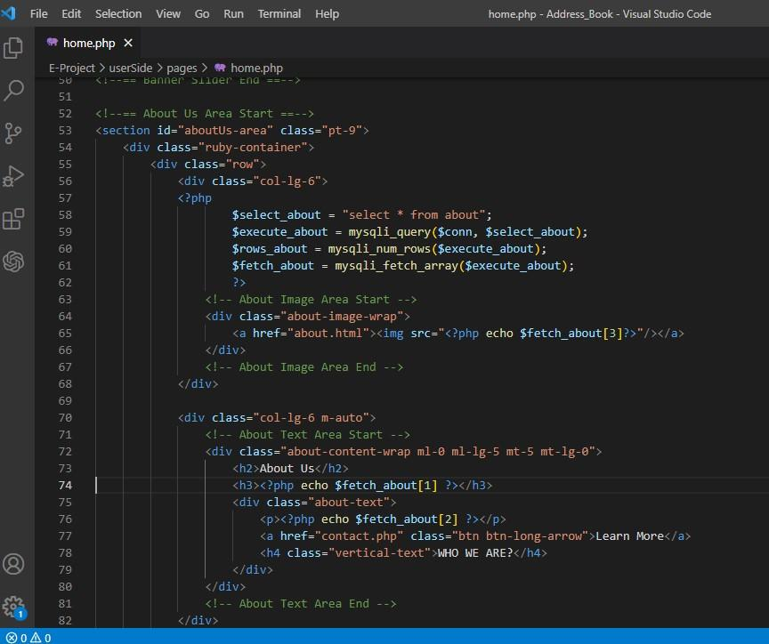

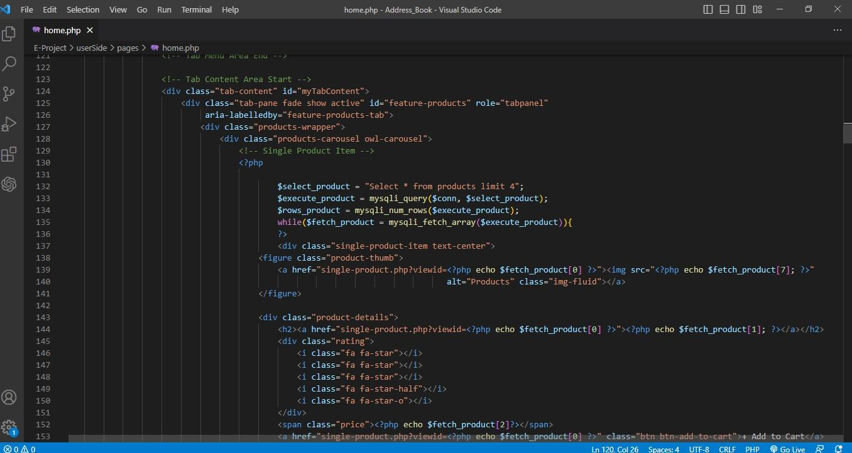



**Header.**

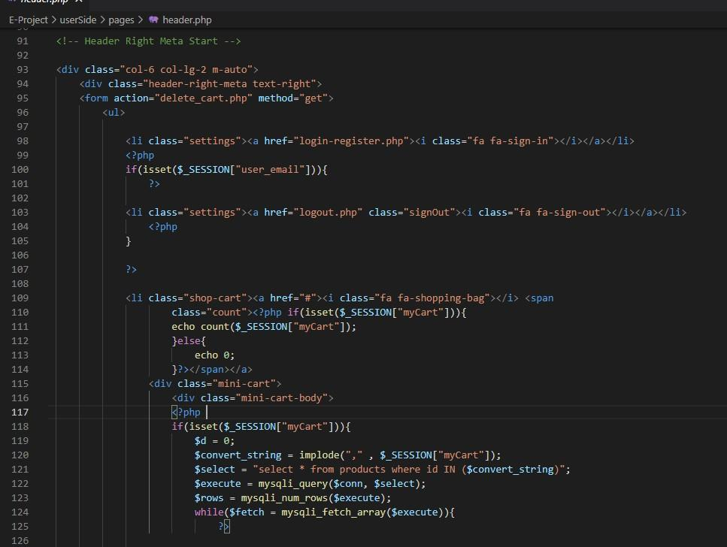

**ADMIN REGISTRATION (display):**



# Registration (user)



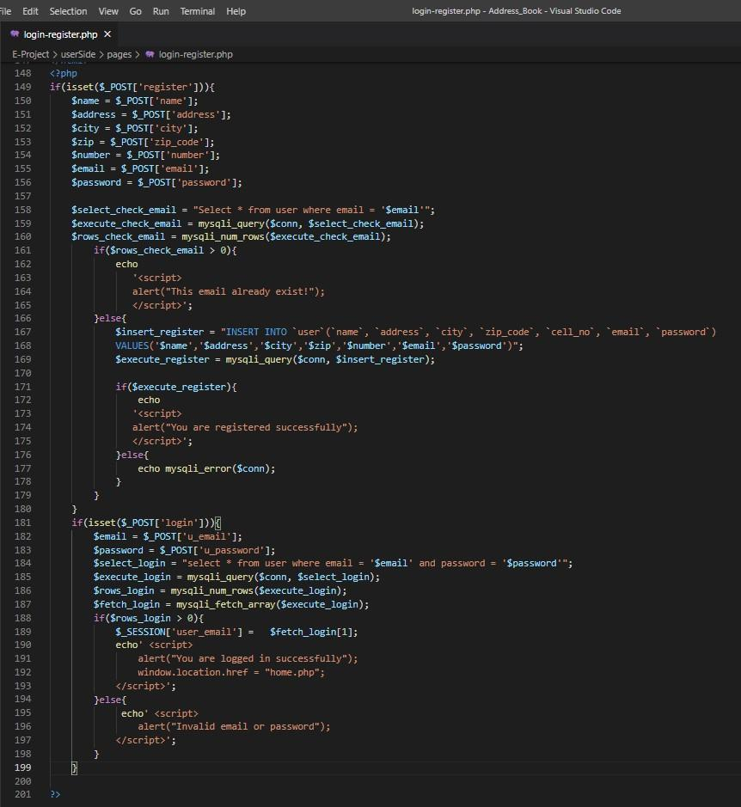

# Brands including (Title page)



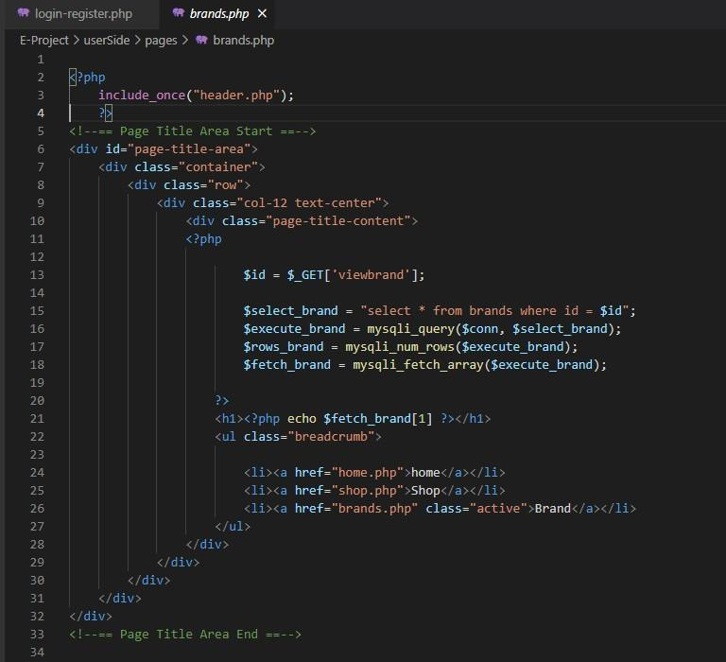

**Shop Area.**

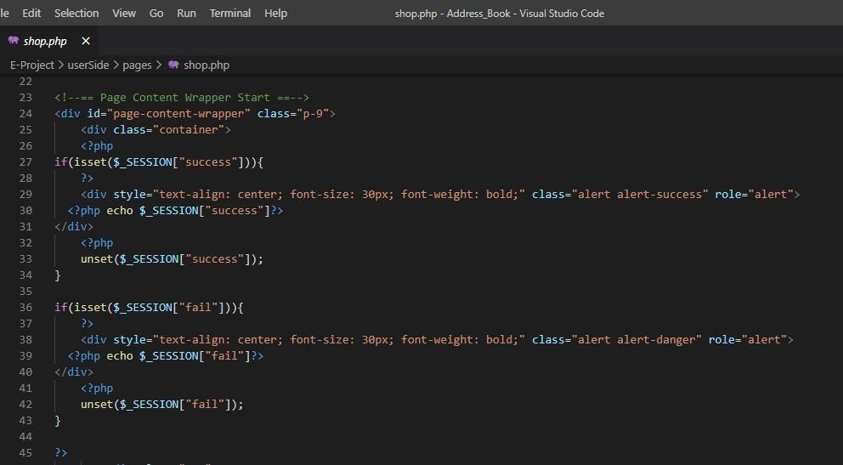

**Brands enclosure**.

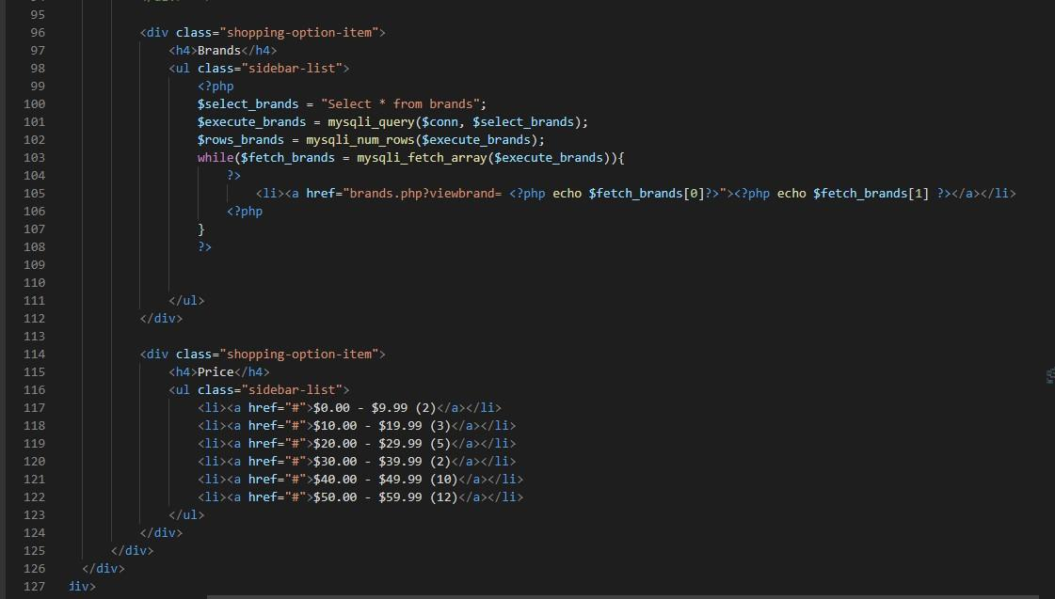

**Add to cart.**

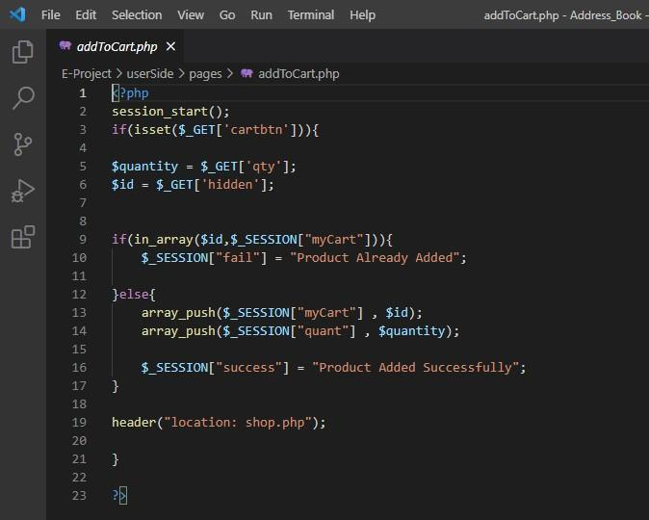

# Delete cart (empty cart, if needed)



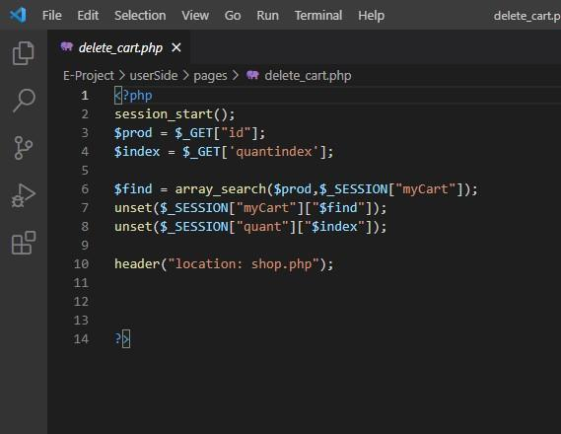

# Add about



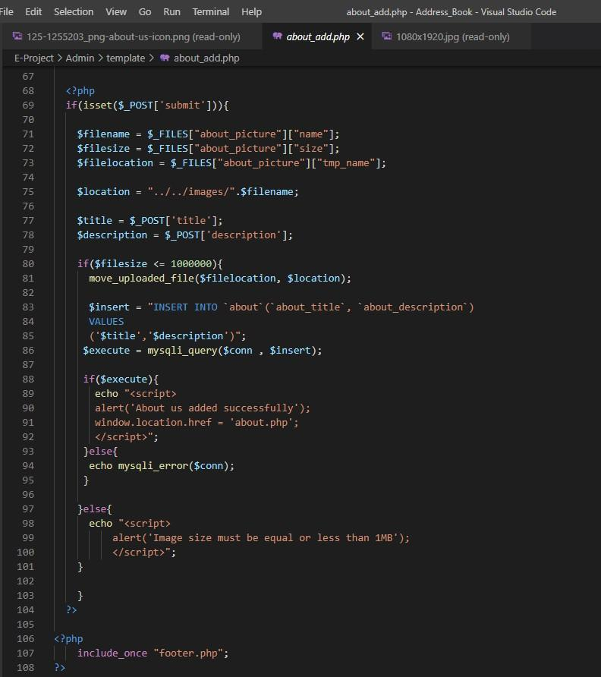

# About Delete

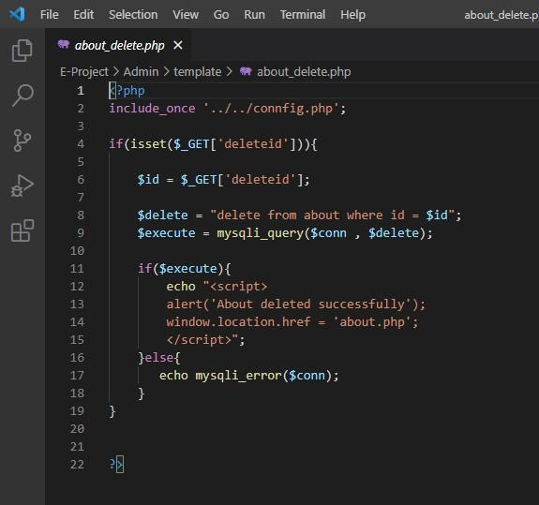

# About update



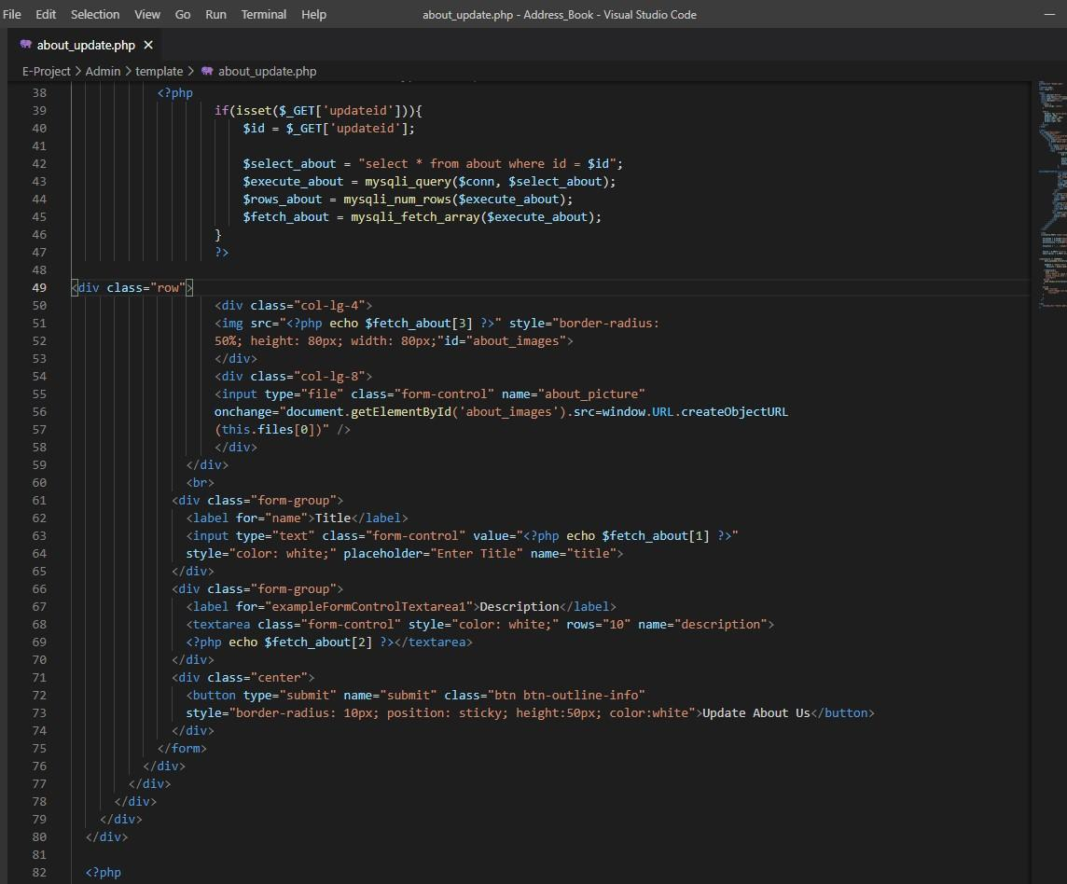

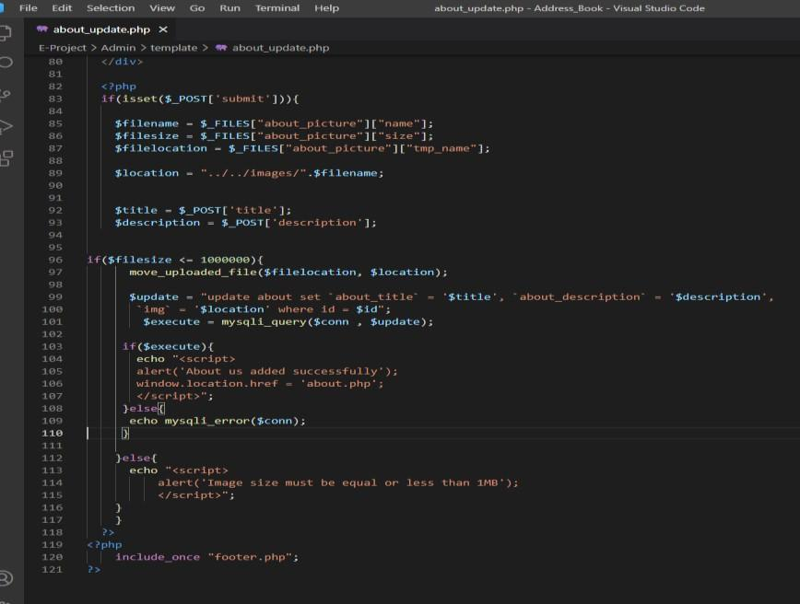

# About page

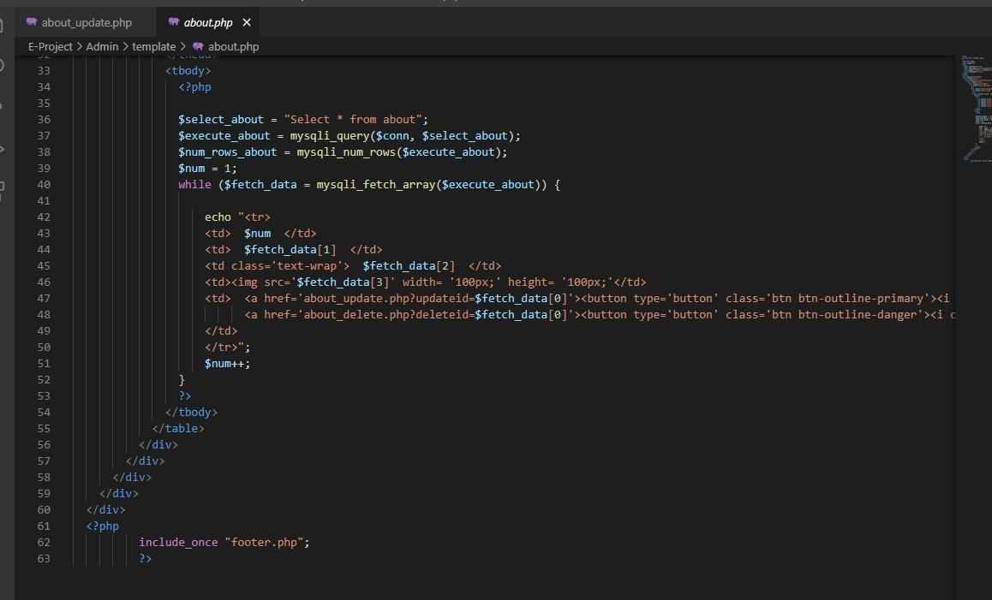

# Single Product (side bar)



# Logout Page

